**C:\Users\sgerrol\AppData\Local\Microsoft\Windows\Temporary Internet Files\Content.IE5\HZQJK2RZ\MC900320652[1].wmf**If you like to ride roller coasters, the description above probably sounds familiar. But did you know that roller coasters aren’t just thrill rides? Actually, roller coasters are examples of the laws of physics in operation. Roller coasters are pulled to the top of the highest hill, then released. A coaster has potential energy as it is pulled to the top, but this changes to kinetic energy as the coaster begins its descent. Gravity and friction control the rest of the ride.

What **physical laws** determine how many hills, curves, and loops a roller coaster track can have?

1. What is KINETIC ENERGY and the equation for KINETIC ENERGY?

2. What is POTENTIAL ENERGY the equation for POTENTIAL ENERGY?

3. According to this Law, energy is never created or destroyed, it can only ___________________

4. What is the name of the law from #3

5. Energy of movement is called __________ energy.

7. Potential Energy and Kinetic energy is measured in ___

8. At the top of Roller Coaster, the object has a [ high / low ] potential energy.

9. At the bottom of the Roller Coaster, the object has a [ high / low ] potential energy.

**Physics Problems:**

[**http://www.physicsclassroom.com/class/energy/u5l1c.cfm**](http://www.physicsclassroom.com/class/energy/u5l1c.cfm)

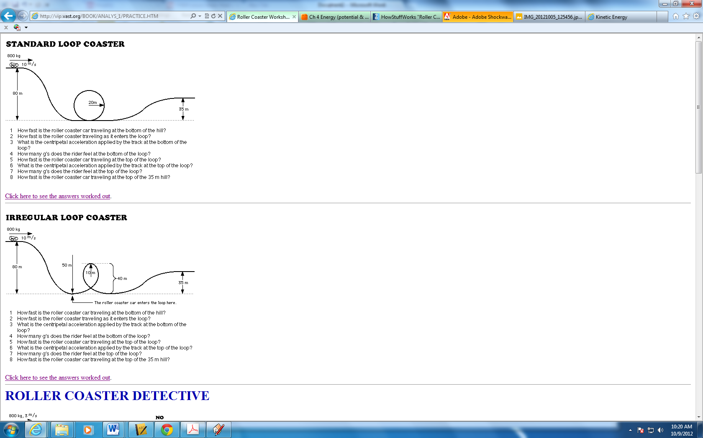

**Sketch the first part of your Roller Coaster below and determine the KE and PE for your own coaster design!**